**POWER BI**

* To generate business intelligence reports
* To analysis profit and loss, sales, data of users etc.

**POWER BI DESKTOP**

* To work with reports and dashboards offline we download the power BI desktop. We can save reports and dashboards connect with various data sources to work with, but to use these reports or dashboards in our application first we need to publish it to the power BI service(Cloud service).
* Dashboard 🡪 visuals from various reports with different datasets can be pinned ina single dashboard.
* Reports🡪 created based on a single data source.

**POWER BI SERVICE**

* To work with reports, dashboards and workspaces in online mood we login to our power bi service account and work on different reports. (pro, premium, free trial)
* We should create a workspace, a workspace is a collection of reports, dashboards and datasets, it also allows us to edit the reports with all the functionalities provided by the power bi desktop.
* “My workspace” is the default workspace, that’s rendered to us when we first create a power bi service account.
* We select publish to web, to publish our report we do this so that we get an id for our report that’s in power bi cloud.
* After getting the id we embed the report in our website or application with the given iframe object.
* The report that we integrated is interactive but we can’t add additional visuals ,refresh data,change colors of our visualization, ie the functionalities and the filters are limited.
* Also to view the report a user must have an power bi service account, this is for security reasons though.

**POWER BI EMBEDDED**

* To embed our reports and dashboard in our app so that external people who don’t have an account in power bi can interact with the report.
* Download the JS SDK, register the application in the azure portal, get the credentials.
* Read the documentation of JS SDK then proceed.
* Since we published our report we have our report id, workspace id is meant for app workspace (this lets you to collaborate with others in a particular workspace) your personal workspace(my workspace) can’t have an id.
* so create an app workspace to get workspace id.

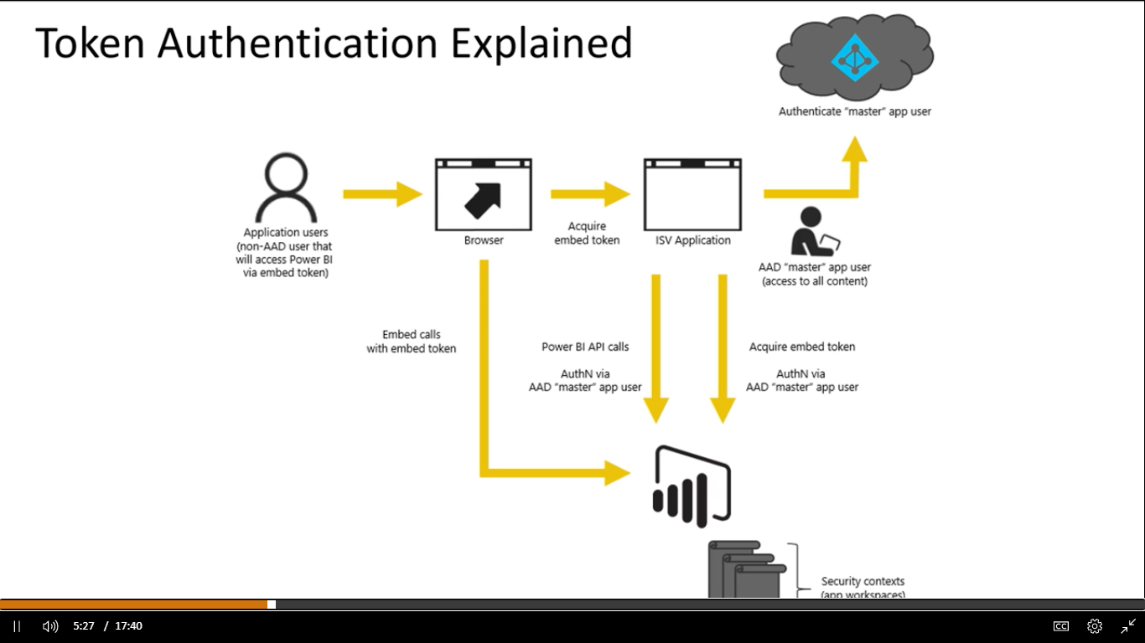

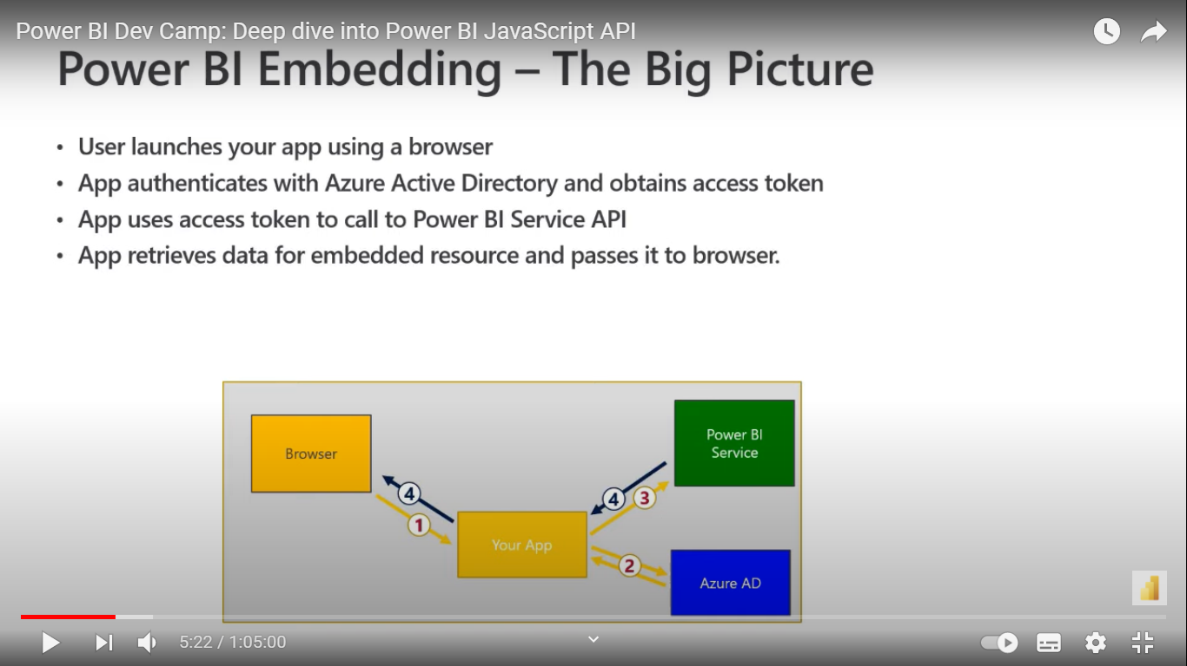

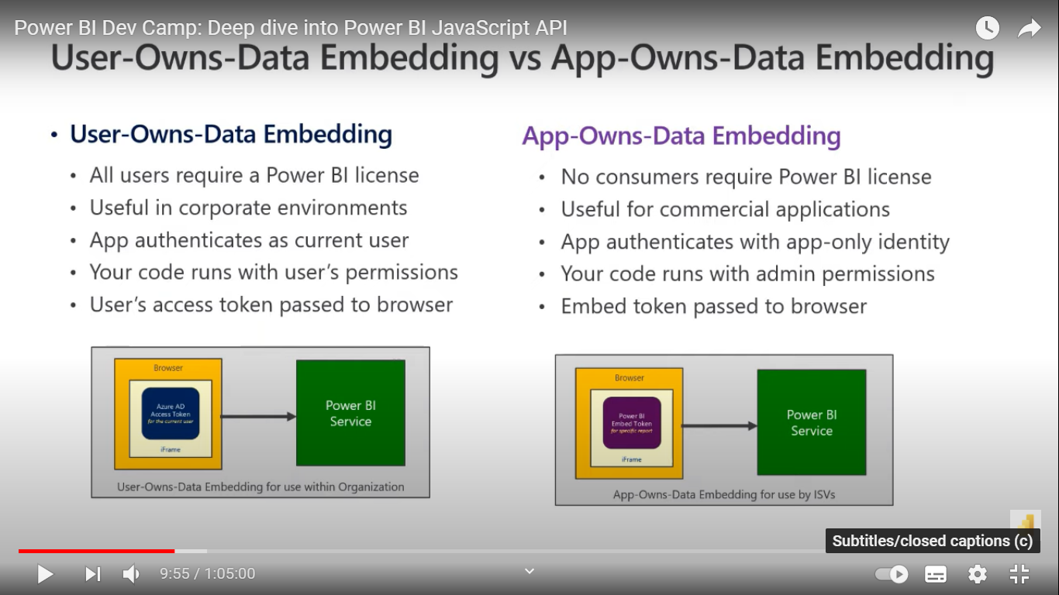

embed token is required for app-own data embedding

app-own-data-embedding🡪 allows external users to access the report we can authenticate the users in our application that has a power bi report ,no user needs an ADD registered.

**Access token** 🡪 provides access to external people to interact with our power bi reports.

**embed token** 🡪 we also allow external people to interact or create visuals in the report, these changes have to be embedded in the report, so we generate an embed token for a report, that’s y we need embed token for app-own data embedding, because app-own-embedding allows to modify the report by an external person.

Inorder to get an embed token

**you have to register an app with Azure Active Directory, then you need to write some code to authenticate with Azure Active Directory (Access Token) and then make the Power BI REST API call to generate the embed token**.

**To access the report (external)🡪 access token**

**To make changes in the report (external)🡪 embed token**

**generate token🡪 api that gets the embed token**.

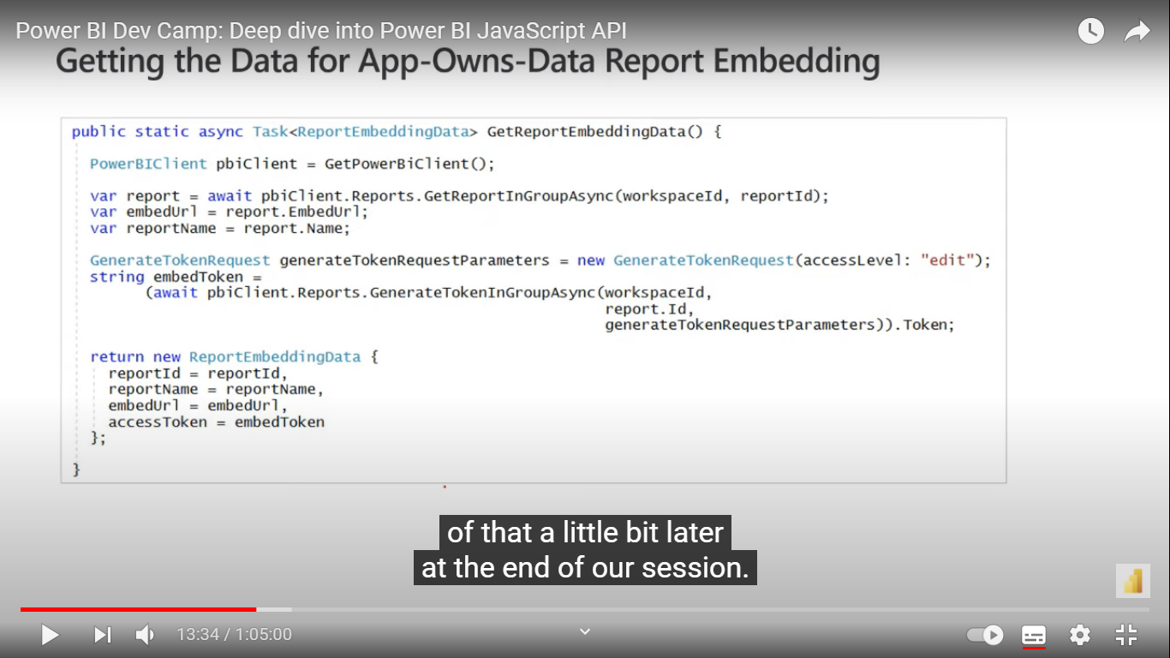

**POWER BI EMBEDDED PLAYGROUND**

* Remember, we download the sdks and work with it so as to provide access to external people to view and interact with our reports.
* So, we need some sort of authentication, that’s y we need an access token to be generated so that people can access the report seamlessly.
* Can interact with report and API’s , see the showcases, get code.

POWER BI LINKS FOR INTEGRATING REPORT:

<https://channel9.msdn.com/Shows/Data-Exposed/Setting-up-and-Getting-Started-with-Power-BI-Embedded?ocid=player>

<https://channel9.msdn.com/Shows/Data-Exposed/Power-Bi-Embedded-with-the-Javascript-sdk?ocid=player>

* Register an application: <http://dev.powerbi.com/apps>
* Demo source code Power BI Developer Samples): <https://github.com/Microsoft/PowerBI-Developer-Samples>
* github repo for JS SDK <https://github.com/Microsoft/PowerBI-JavaScript>
* Live demo sample page <https://microsoft.github.io/PowerBI-JavaScript/demo>
* official documentation <https://powerbi.microsoft.com/en-us/power-bi-embedded/>

**APP VS WORKSPACE**

<https://www.youtube.com/watch?v=n-9e8AtbSsM>

JAVASCIRPT APIs

<https://channel9.msdn.com/Shows/Data-Exposed/Power-Bi-Embedded-with-the-Javascript-sdk?ocid=player>

EMBEDDING WITH POWER BI

<https://www.youtube.com/watch?v=0y2oJikC6Xc>

EMBED A REPORT

<https://www.youtube.com/watch?v=V9Xp0X7hLBk>

POWER BI DEVELOPER SAMPLES GITHUB

<https://github.com/microsoft/PowerBI-Developer-Samples>

POWER BI PLAYGROUND UPDATE:

<https://www.youtube.com/watch?v=5ikWESY4sHc>